Installation of the Lamella System
This report has been written to document the step by step installation of the lamella system inside T70 tank at SweSwe treatment plant, Kyaka refugee camp, Uganda. The installation of the lamella has been done between 24th March and 1st April 2021.

PART 1: BUILDING THE LAMELLA BLOCK
Step 1: Receiving the Lamella Consignment from Kampalla.
A truck had delivered a package of loose Lamella profiles and T70 tank kits at SweSwe treatment plant on 24th March 2021. The lamella package in wooden crate consists full and side profiles and one soldering iron.
Thus, the packages were carefully off loaded from the truck and stored safely. The side profiles were kept separate from the full profiles as shown in the picture. This was to avoid a risk of mistake of using the side profiles as a full profile. The red colour marks at both ends of the side profiles makes it easy to identify between side and full profile.
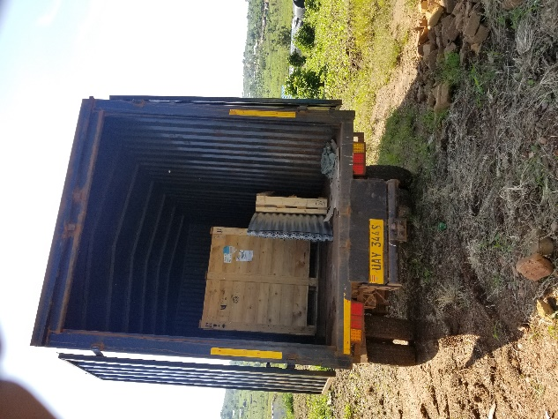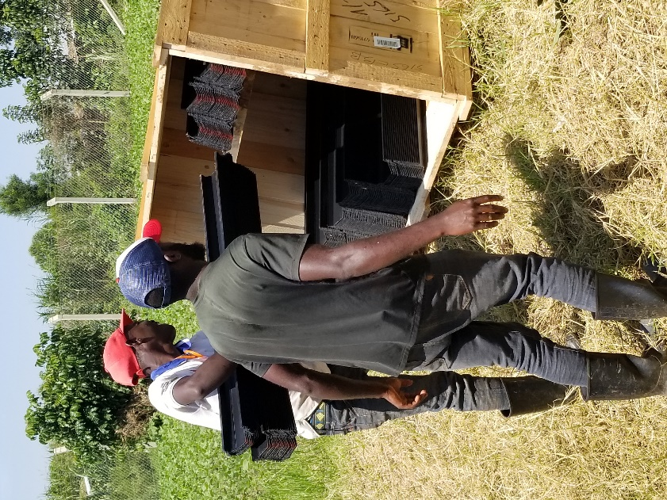

Step 2: Separate side profiles from full profiles.
Side profiles can be identified with its red marked at both ends and has two white cutting lines along the length. Put them separately.

Step 3: Two side profiles (left and right) come attached. Cut out the side profiles of full profiles and put them separate.
The side profiles come as full profiles but it’s red marked and flexibility unlike the rigid full profiles. The side profiles were cut out of full profiles and put separate for welding at both edges of each layer of the welded lamella tube blocks. The right and left profiles differ from each other and as a consequence the right-side profile can’t fit on the left side and vice versa.
Caution: Avoid wrongly using full side profiles as full profile in building the tube block. This can be achieved first cut out the side profiles from its full profile, or by providing proper orientation of the team working with or close supervision of the welding process.
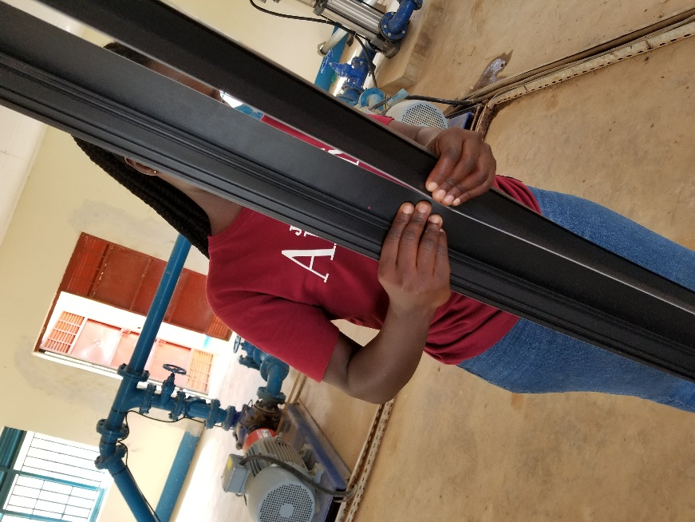
Step 4: Setting Out
Place five full profiles on assembly table (we used two T70 tank crates as a table to demonstrate the assembly) and bridge adjust two full profiles by a bridging similar full profile by sliding with its tongue and groove system – this forms the first layer as indicated in the picture below. And similarly slide side profiles at the edge of both ends of the first layer.
- Measure the full first layer to be 1.2mx1.2m

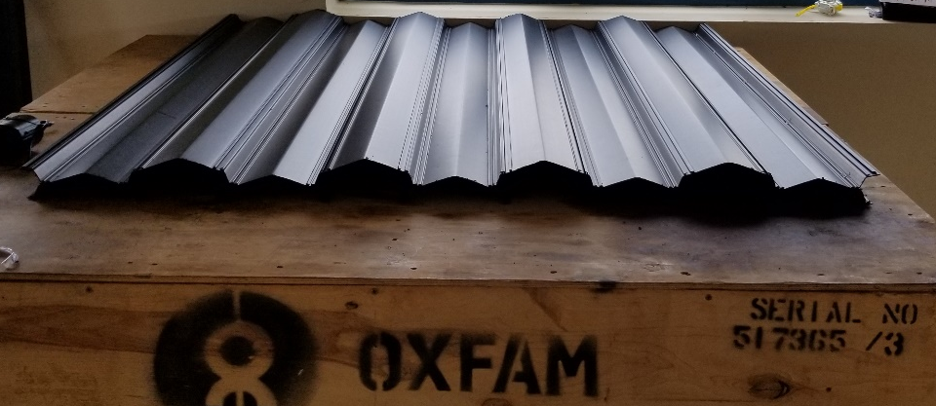

Step 5: Welding the joints
- 4 welds in each side of full profiles to stop the sliding along the tongue and groove joint. 20 joints per tube layer and a total of 27 layers of tubes to form 1.2m = 4x20x27= 2160 welding pints.
- Used electric soldering iron for welding.
- The soldering iron delivered with the package was 120v while the standard in Uganda is 220 – 220v.
- We used 3 locally available soldering iron to build the blocks. It took us 3 days for 5 blocks. We employed two person and one soldering iron per block.
- One soldering iron will take two days to build one full lamella tube block. Thus, it would take at least 10 days to finish 5 blocks. For quick installation of the whole system in emergency contexts, use multiple number of soldering irons to finish the blocks quick.
- The size of the soldering iron should be 3mm to 5 mm welding iron size.
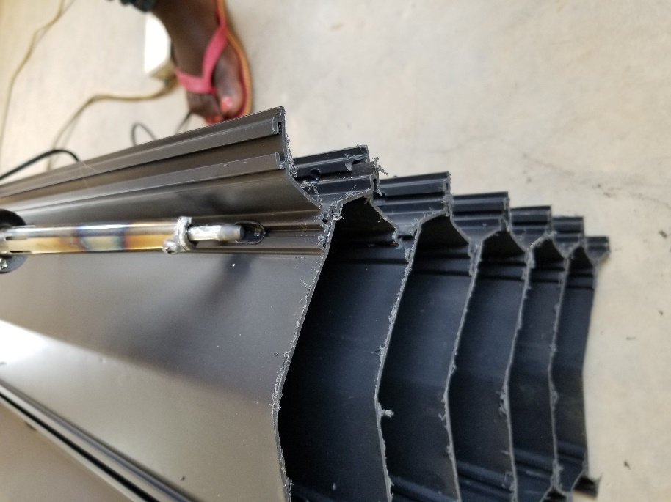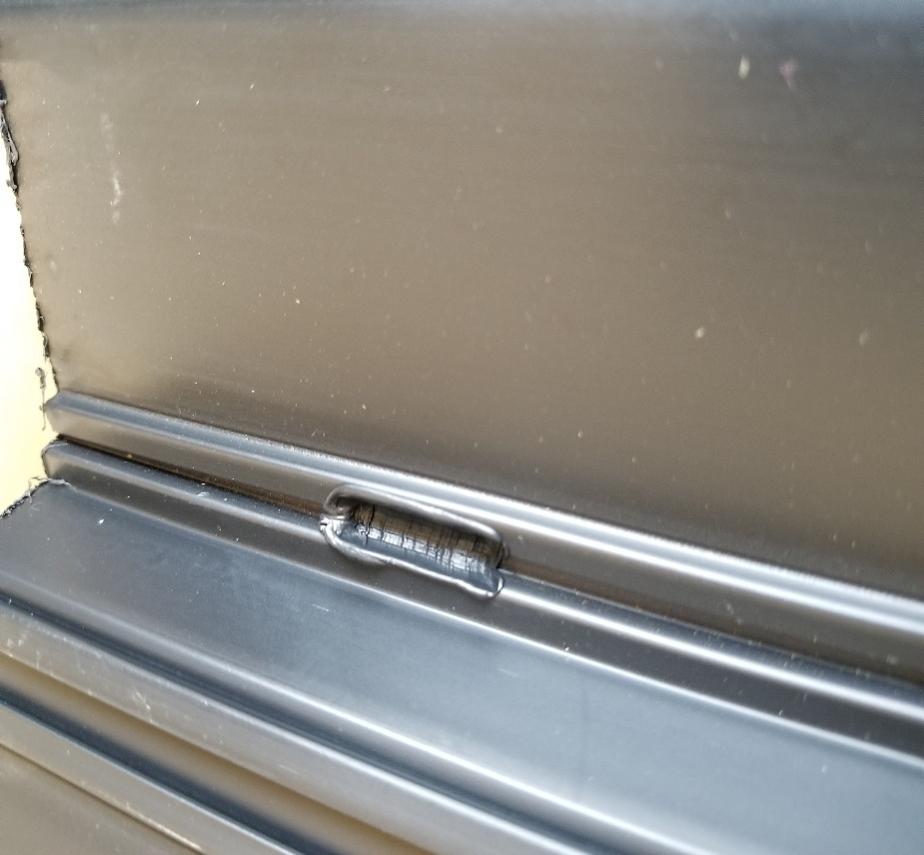

Welding of loose lamella profiles in two tube blocks with soldering iron is pretty much straightforward. Any person in the field can be trained quickly to do the work right away. However, the welding process is slow and time consuming (about 2160 welding points).
In the event that electricity is not available on site, we found out that the same soldering iron can be powered from a vehicle battery.
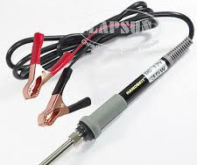
Step 6: Completing Lamella blocks
After setting up the first template of the lamella block, repeated step 3 to 4 and continued building the tubes layer by layer until achieved 1.2mx1.2m tube block. Each layer consists of 9 tubes and there are 27 layers within a completed block. A T70 tank this requires 5 full lamella tube blocks.
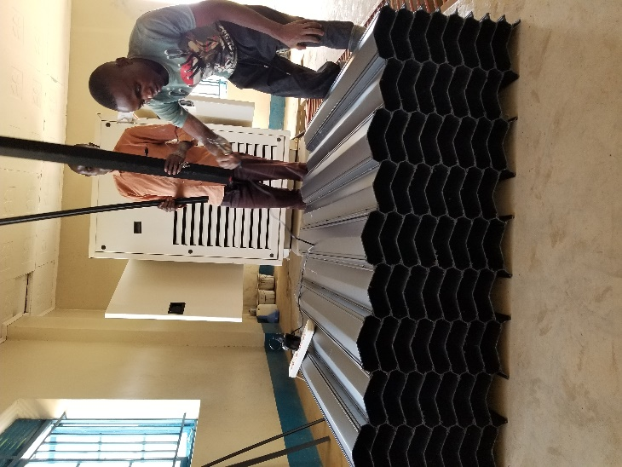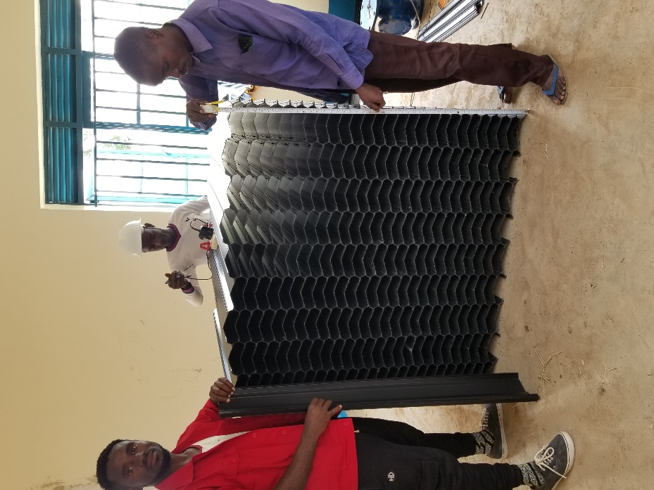

Note: Each layer contains nine full profiles and two side (half) profiles which slot together in tongue and groove joints (before welding) creating alternating offset tubes. Basically, repeating this combination shall build the whole tube blocks.

Step 7: Transport to Site
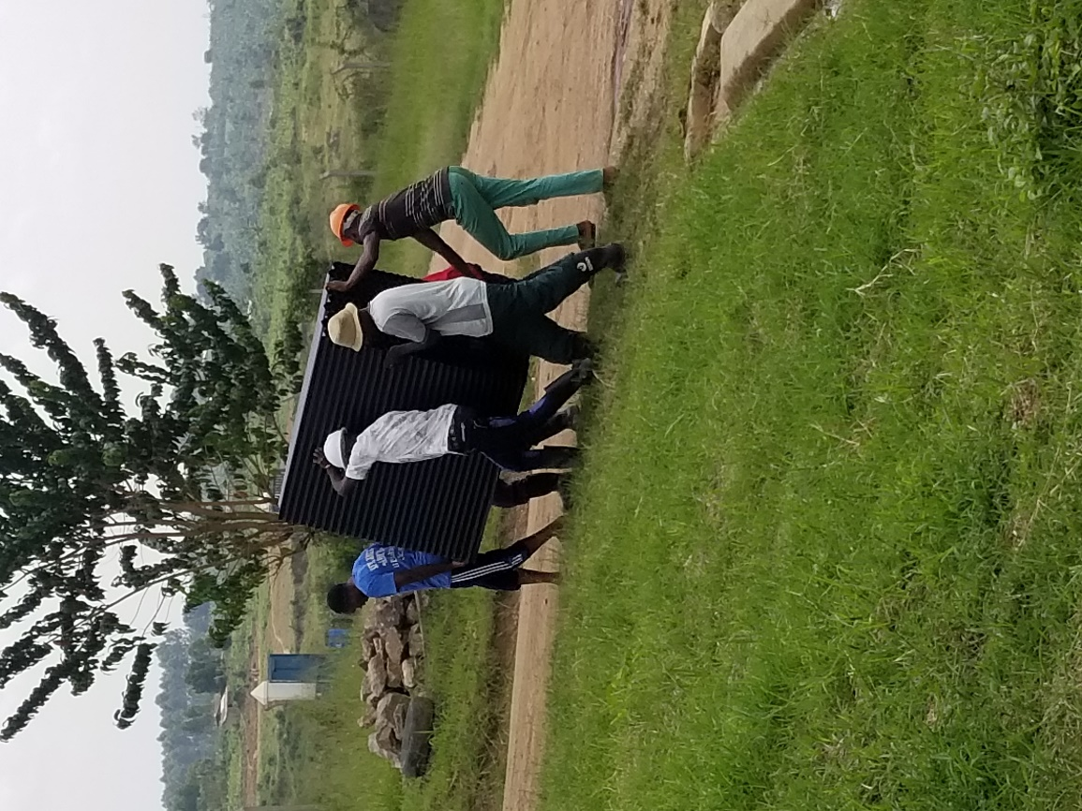
Transporting all 5 lamella tube blocks from the pump house where it’s assembled to installation site where T70 tanks installed. Care needs to be taken during welding, transport and installation, but once welded as a block, the lamella tubes are strong whilst retaining some flex

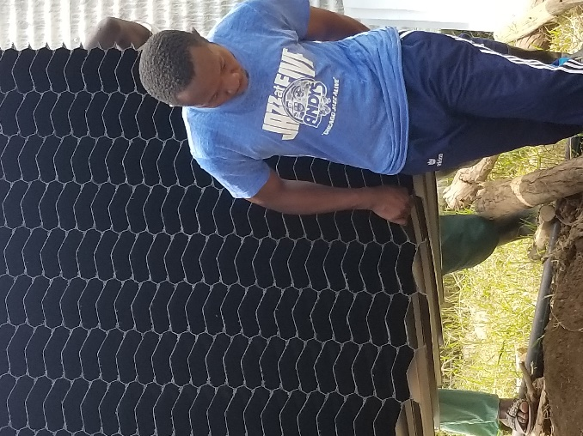
Step 8: Assembling Sample Stanchions and metal wall plates and Mounting one lamella block
- A sample of three Stanchions and metal wall plates were assembled, and the finished lamella block were mounted on top as demonstration.
- The installation team were also trained on how to finally assemble the blocks and the stanchion frames inside the tank.
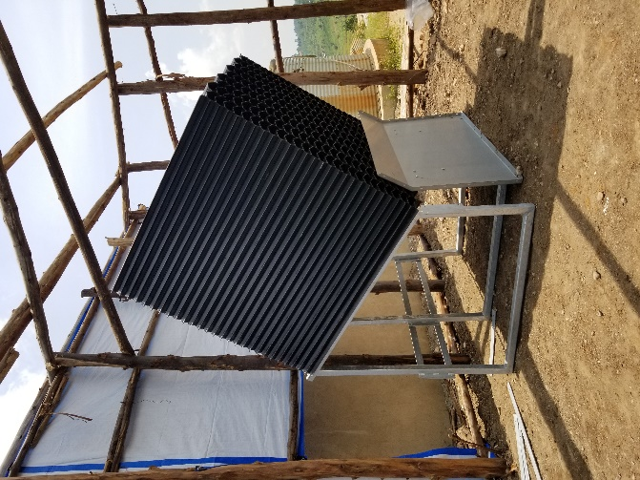

PART 2 – ASSEMBLING TUBE SETTLER SYSTEM INSIDE A T70 TANK
Step 1: Assembly of T70 Tank
- New T70 Tank with liner has been installed on a concrete platform. The platform was already constructed.
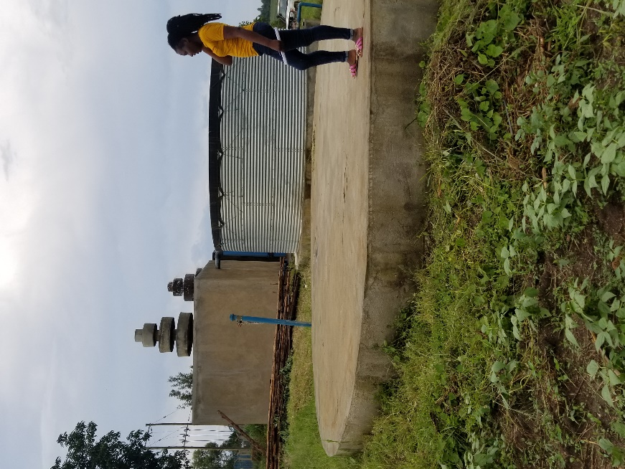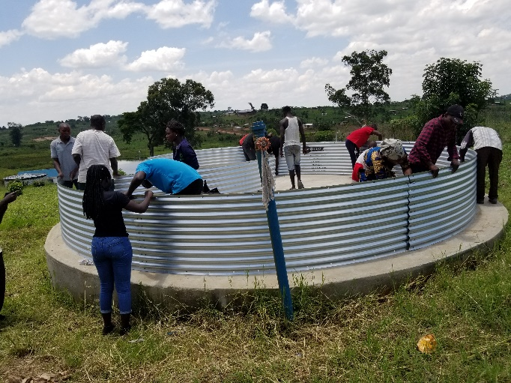
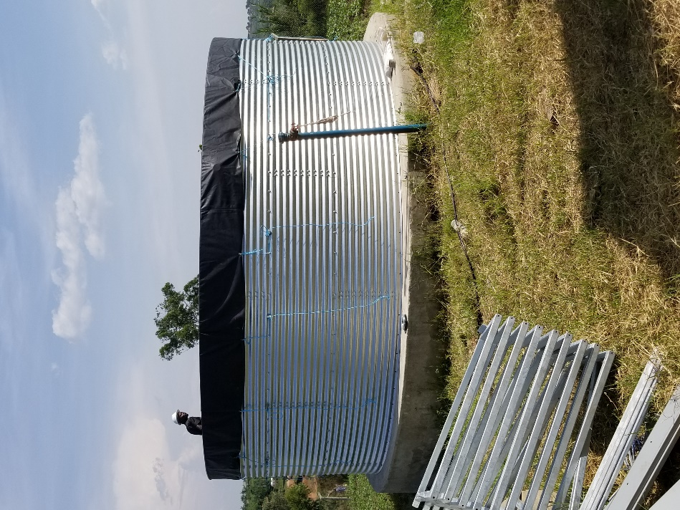
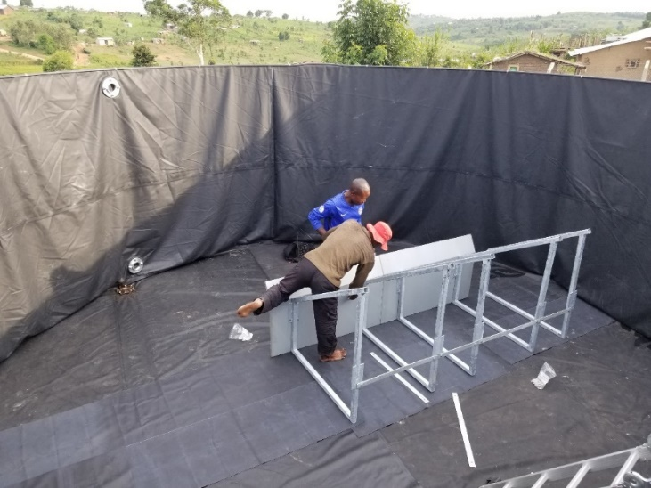

Step 2: 10 Stanchions were installed along the centreline inside the T70 tank and 10 fixation bars, 5 of them are shorter were attached with the stanchions to keep the distance and rigidity. Back-wall plates were attached along with the stanchions frame.
Note: Additional liners were placed on the floor and side of the tank to protect the liner from any possible punctures
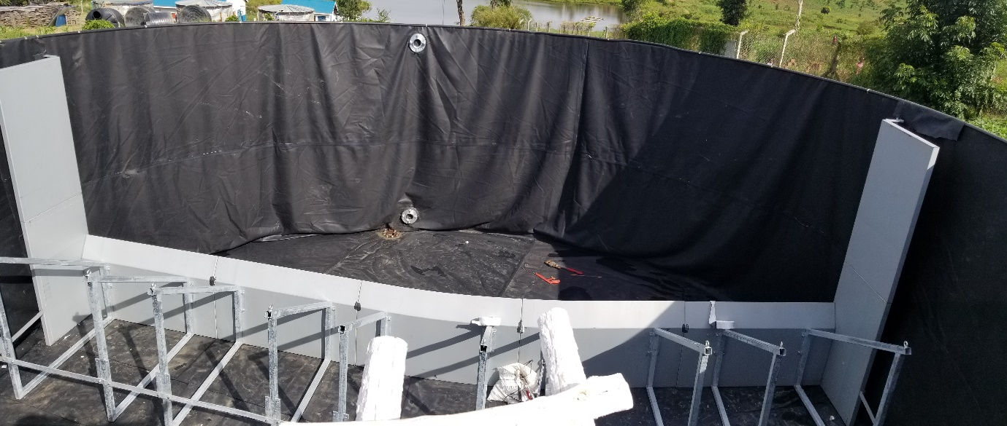
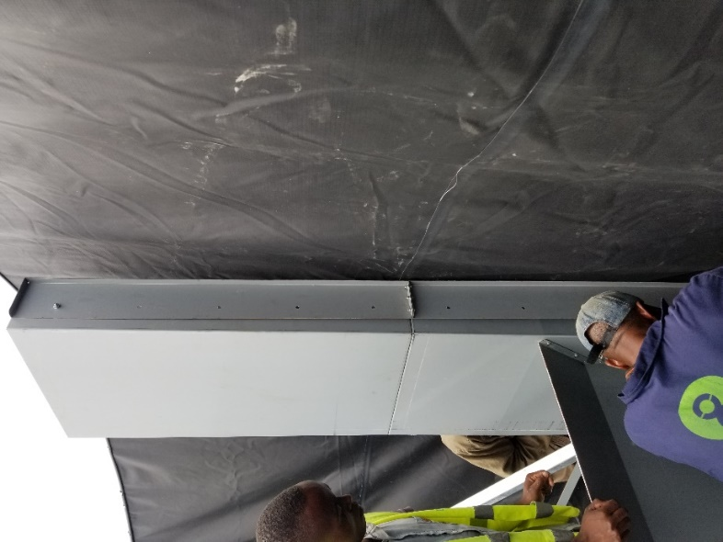
Step 3: Side walls and brackets were attached to the stanchions at both ends.
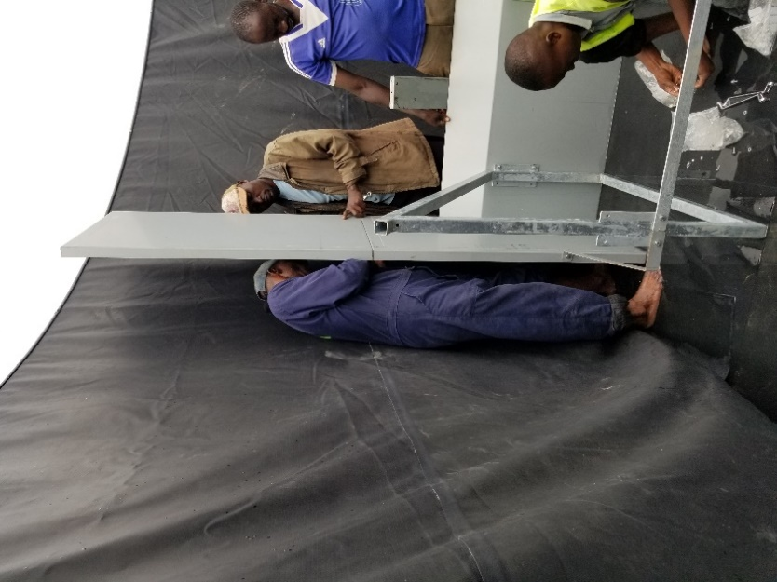
Step 4: Afterwards, adjuster plates were attached.
Step 5: Closing the gaps between the tank and the adjuster plate
The adjuster plate was able to close the gaps with the tank wall at the bottom half, but there was significant gap at the top half. The gap was closed using the liner maintenance kit (adhesive and liner piece, as indicated in the picture below).
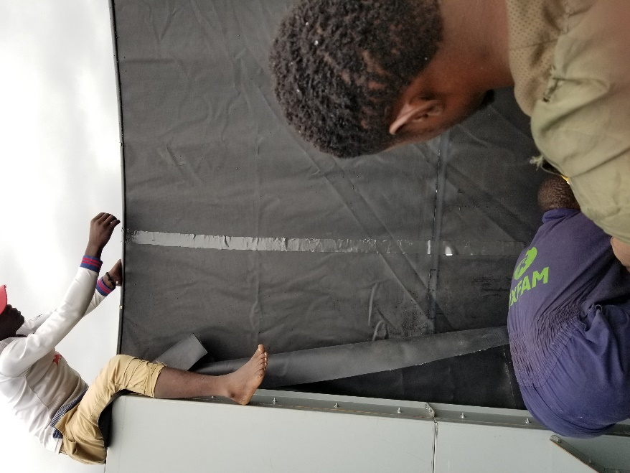
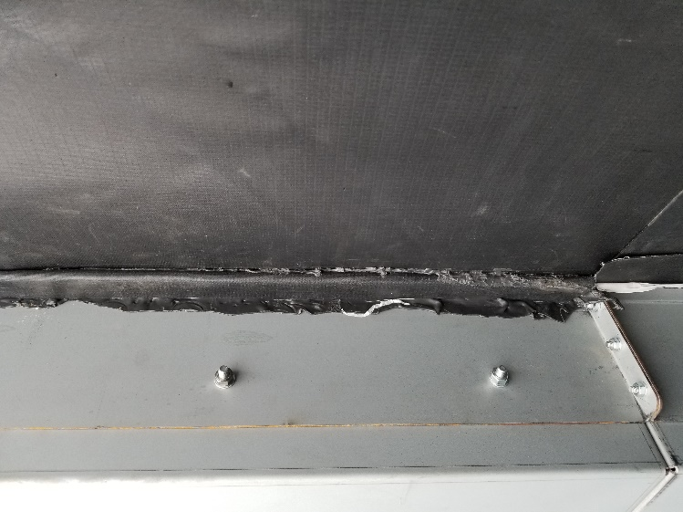
Step 6: Five Tube Settler Blocks were placed on the inclined stanchions
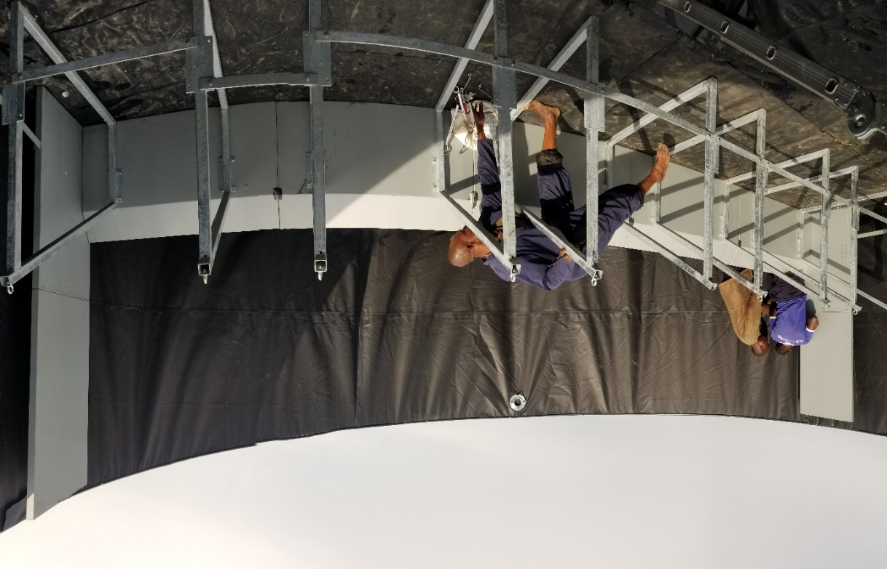
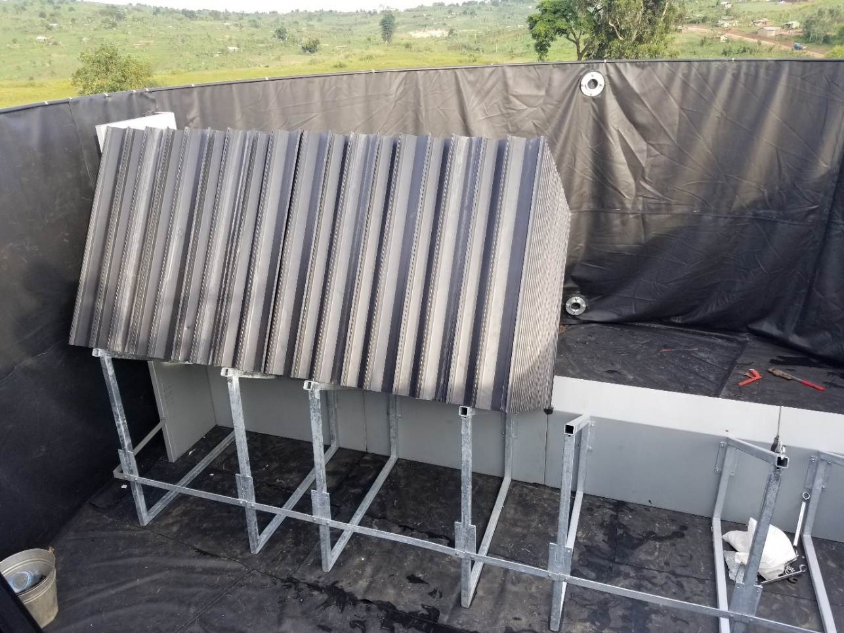

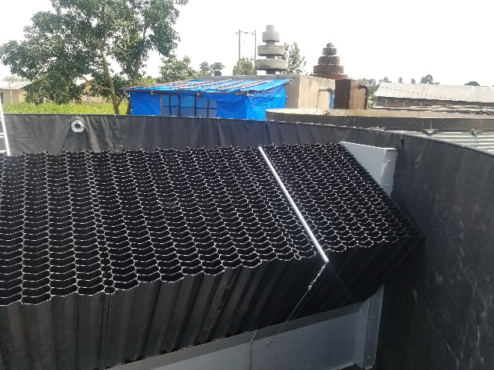
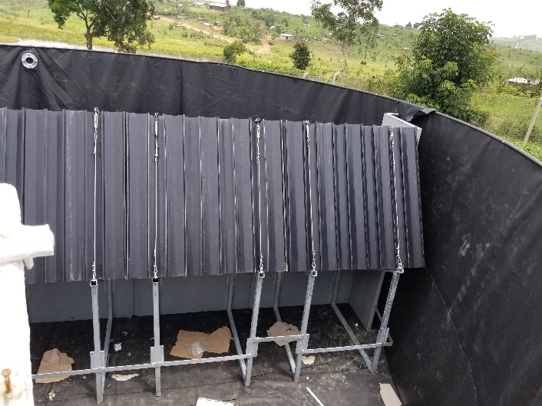
Step 7: The tube settler blocks were attached with stanchions and back plates with steel cables

