Testing Report – Lamella Tube Settler, Kyaka Refugee Camp – SweSwe Treatment plan

Table of Contents
Testing Report – Lamella Tube Settler, Kyaka Refugee Camp – SweSwe Treatment plan 1
Background Information 2
Modification of The Pressure Main – Bypassing the Aerator 4
Testing of The Lamella System 5
Rationale of the Inlet Diffuser Pipe Design 6
Alum Dosing and Stock Solution 7
Testing the Lamella System at Various Flow Rates 8
Discussions on Test Findings & Feedbacks - 1 12
Discussions on Test Findings & Feedbacks - 2 14
Key Challenges Identified 14
Way Forward Actions 15
Identify Source and Cause of Short Circuiting of Flocs 21
Identify Causes for short Circuit of Flocs at the Lower Tubes Outlets 22
CONCLUSIONS 25
RECOMMENDATIONS 25

Background Information
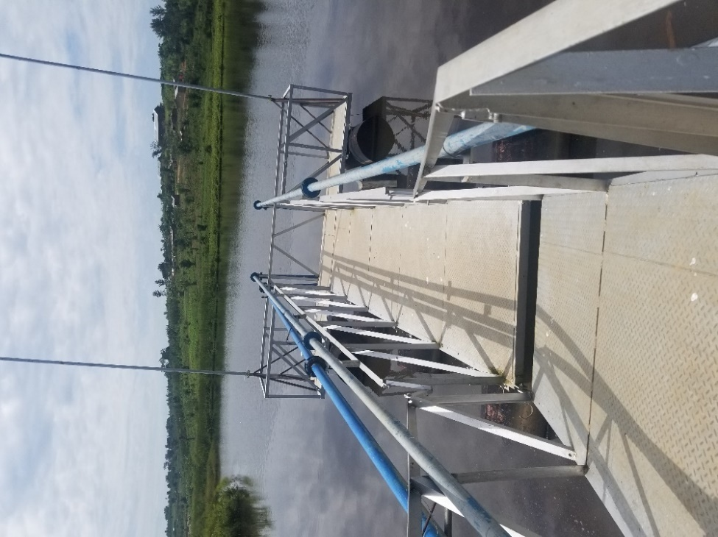
Kyaka II refugee settlement is located in Kyegegwa district, South Western Uganda. It is about 225 km from Kampala by road off the Mubende - Fortportal highway. The settlement currently hosts more than 124,000 refugees (majority Congolese).
The Kyaka II water supply system composed of water distribution system from two treatment plant and multiple shallow wells fitted with hand pumps. The water treatment system is mainly from SweSwe water treatment plant that serves most of the water need in the settlement.
The SweSew water treatment plant is composed of:
- A water source for the treatment plant is from reservoir at SweSwe dam.
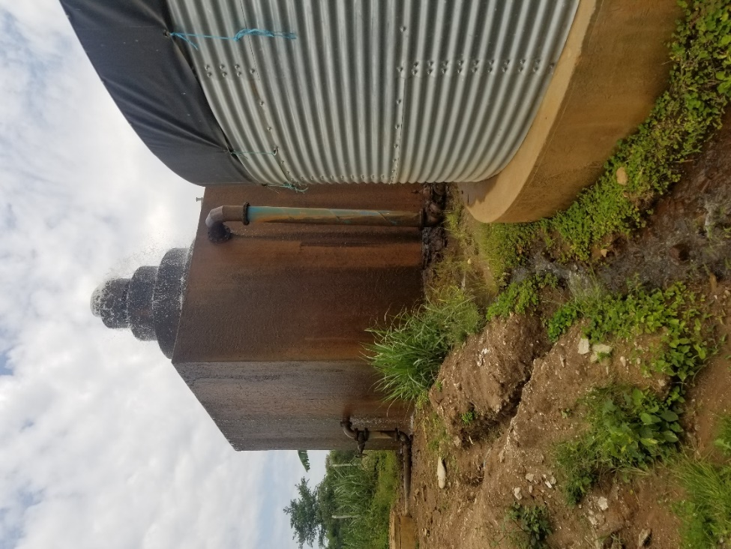
- An Intake pumping system – two 3’’ intake suction pipes
- Discharge Piping to the Aerator – 3 surface pumps are installed in the intake pumping house
- An Aerator for removal of Iron
- Flocculation and Sedimentation tanks – Six T70 tanks
- Clear Water tanks – 3 T70 tanks
- Clear water pumping to distribution reservoirs located in three location in the settlement.
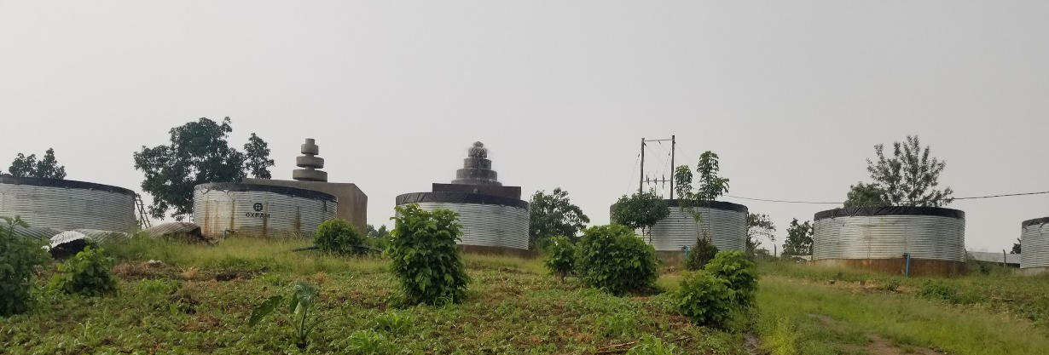

Current Operation of SweSwe Treatment Plant
- At the Intake – only one pump is operational and the other two are not – Pumping rate is 40m3/hr at the water meter in the Pump house.
- The raw water pass through the aerator for excess iron concentration removal. Flow rate at the aerator is 35m3/hr.
- The raw water from the aerator flows down to the T70 tanks via gravity.
- It takes from 4 hrs to more than 30hrs . the nearest tank to the aerator fills faster. The 3’’ pipe connection between the outlet of the aerator and the tank has restricted the tank filling.
- Batch Alum dosing and lime treatment is done on each T70 tank. It takes 4 to 5 hrs to clarify the water.
- Alum dosing was established based on Jar test – 10kg of Alum powder mixed to one full T70 tank.
Rationale of Testing the Lamella Clarifier
- The existing batch treatment plant requires more than 20hrs of pumping to produce 406m3 of water per day engaging all six T70 tanks as flocculation and sedimentation. The lamella clarifier is therefore aiming to improve the clarifying process by continues clarifying process by establishing steady state inflow and outflow and replace all the six T70 tanks with one Lamella tank.

Modification of The Pressure Main – Bypassing the Aerator
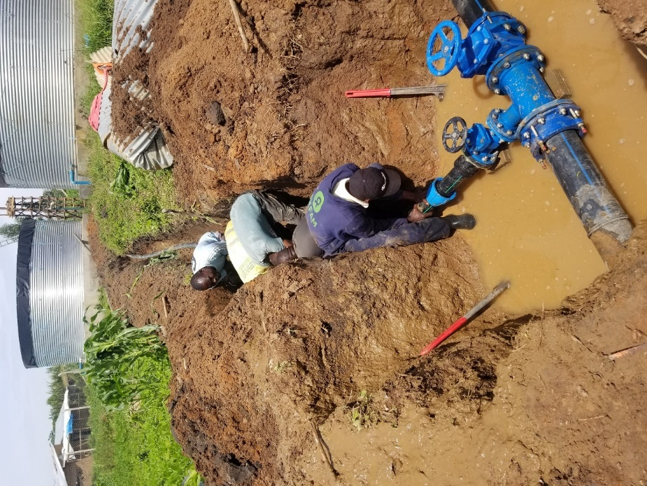
As indicated The flow rate from the aerator at inlet to the lamella tank was measured at max 6 m3/hr. This follow rate wasn’t good enough for testing the lamella tube settler system which is designed for an inflow rate of up to 45 m3/hr.
Modifications has been made on the existing pumping main pipeline to connect the tube settler system directly from the source bypassing the aerator and bypassing the aerator. This was done by connecting 3’’ GI flanged reducing tee (6’’ -3’’ -6’’) branching from the 6’’ GI pipe pumping main from source to the aerator. Two flagged gate valves (3’’ and 6’’) were also installed for flow control between the existing aerator system and testing lamella system.
The 3’’ branching pipe connected to the lamella T70 tank and another adjacent normal T70 tank. This enabled parallel run of lamella and T70 tank during the testing.
Picture1 – connecting the lamella tank with the pressure main and installed flow control valves

Testing of The Lamella System
Having the branching completed, the first pumping towards the lamella tank was made primarily to check:
- The overall flow rate of raw water at the tank inlet
- The overall integrity of lamella system in general before running the actual tests.
The flow rate at the lamella tank was measured at 35m3/hr @the tank inlet and 40m3/hr at the pump house (water meter reading).
Despite our effort to close the major gaps between the T70 tank and the lamella clarifier system installed inside the tank, during the installation phase, mainly: a) between the adjuster plate and the tank wall, b) side wall plates and tube blocks c) stanchions frame and tank floor d) contact area of the tube blocks with back plate, etc. at first pumping of raw water to the tank however it was observed that considerable amount of raw water was flowing as seepage to the effluent side chamber of the tank easily and flow currents through the gaps. As a result, the water level at both chambers raise equally and almost similar turbidity level as it raises.
Further effort was made to seal the remaining gaps as much as possible throughout the day, we mainly used pieces of liner and adhesives repair tape to seal gaps and to hold the side plates/adjuster plates with the tank wall and floor. And also, the gap at the contact between the inclined section of back plate and the tube blocks.
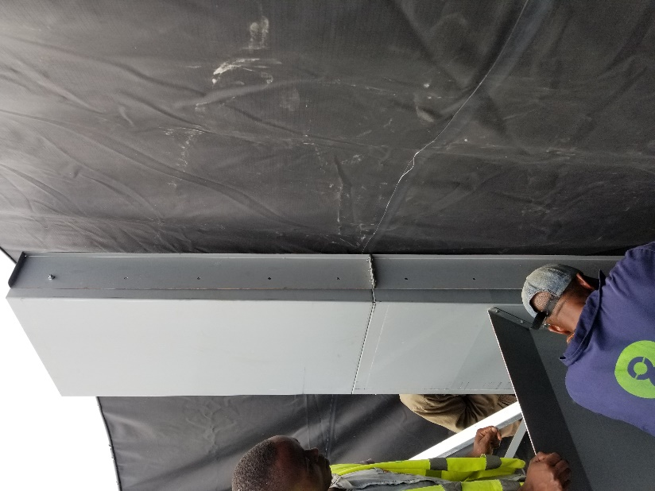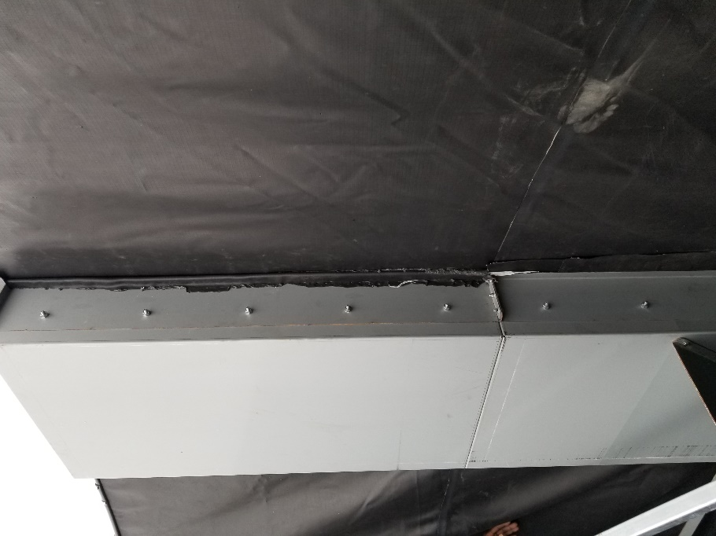
Picture2 – Closing the Gaps between the tank and the lamella adjuster plate

Rationale of the Inlet Diffuser Pipe Design
The inlet pipe to the tank was designed based on the principle that the incoming water flow into the clarifier basin must be evenly distributed in the influent area (prior to tube settlers) to prevent short-circuiting. Short-circuiting must be avoided because it causes water to bypass the normal flow path through the basin and tube settlers so that it reaches the outlet in less than the normal detention time. Even more important, the inlet must provide conditions that avoid floc break up. If the water velocity is greater than 0.5 ft/sec (0.15m/sec), then flocs in the water will break up due to agitation of the water. Breakup of floc in the sedimentation basin will make settling much less efficient
The inlet diffuser was then made perforated with each hole is about 3cm diameter and a total of 156 holes in the whole diffuser pipe.
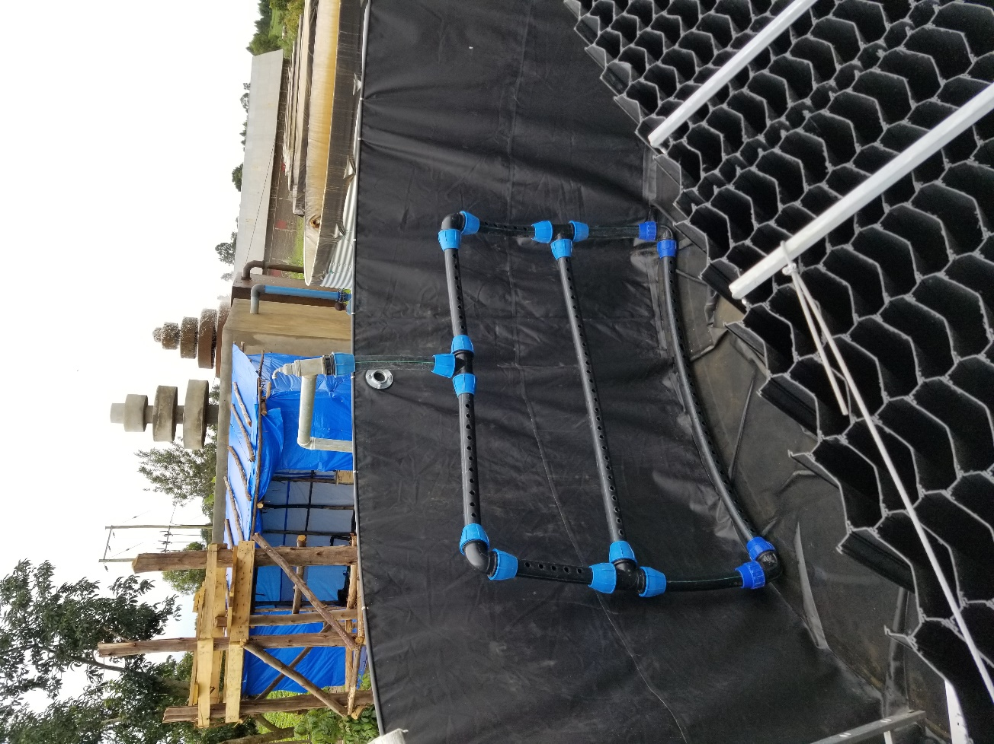

Alum Dosing and Stock Solution
Suction side Alum dosing has been arranged. 100 litre PE tank for stock solution was connected with ½” hose pipe to the suction side of the raw water pumps at the pump house. Two flow control valves (one at the tank outlet and the other at inlet to the suction side of the pump) at both ends of the hose pipe were installed. The valve at the suction side of the pump were used to calibrate the dosing rate of Alum solution.
Raw water sample were collected at the source and after the aerator for lab testing. The samples were sent to nearby laboratory at Mobende town for testing. The sample test includes jar test for Alum dosing and other parameters.
Table: Water Quality Test Result Table
 | Colour | Turbidity | TSS | Iron | PH | EC | Res.Alum
Aerated raw water | 667 | 54.8 |  |  | 6.73 | 155.6
Final water at clear water tank | 64 | 4.13 | 4 | 0.89 | 6.02 | 245 | 0.268
Standard | 15 | 5 | 0 | 0.3 | 6.5-8.5 | 1000 | 0.2
Alum Jar tes | - 140mg/l@60-70 NTU  - 90mg/l@54 NTU

Stock solution were prepared based on the jar test result and turbidity level of the raw pumped. Average turbidity level of the raw water is 60-70 NTU. Thus, 10kg of alum powder is mixed in 100 litre tank and released at the suction side of the pump. The dosing valves were calibrated to ensure that one full 100liter alum solution is released until the T70 tank is full.
Note that the water source has excess iron concentration and the connection was set up for the purpose of testing turbidity reduction performance of the lamella tube settler.
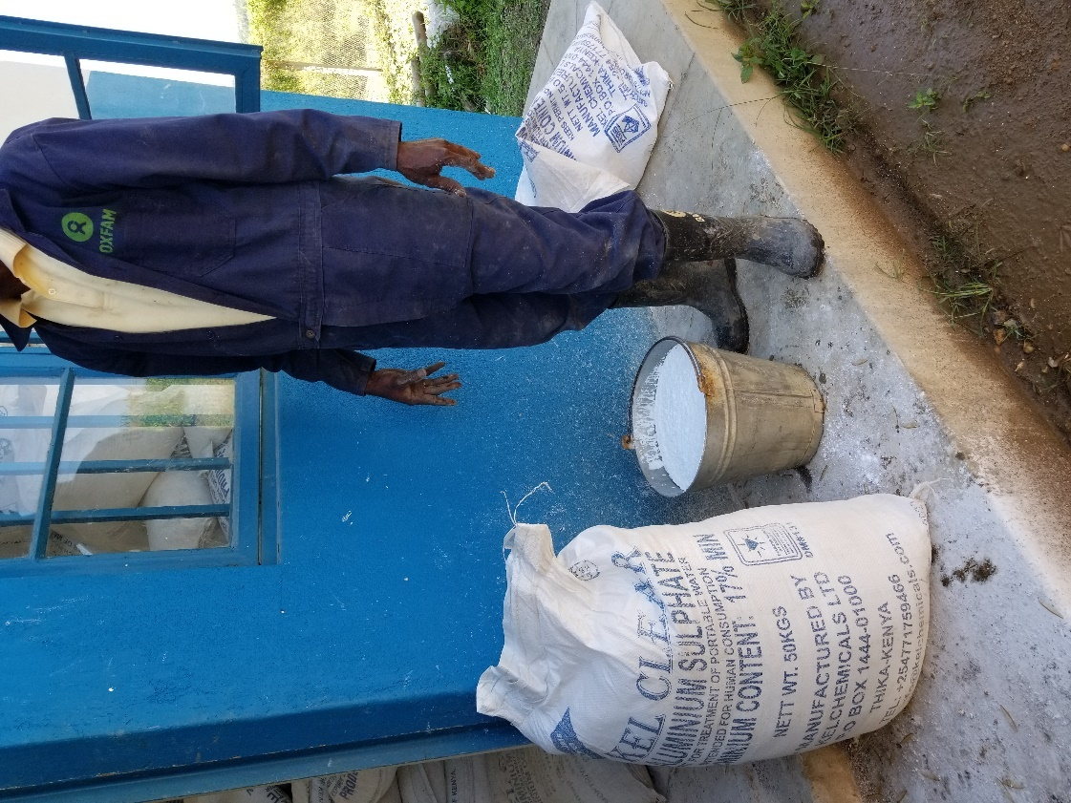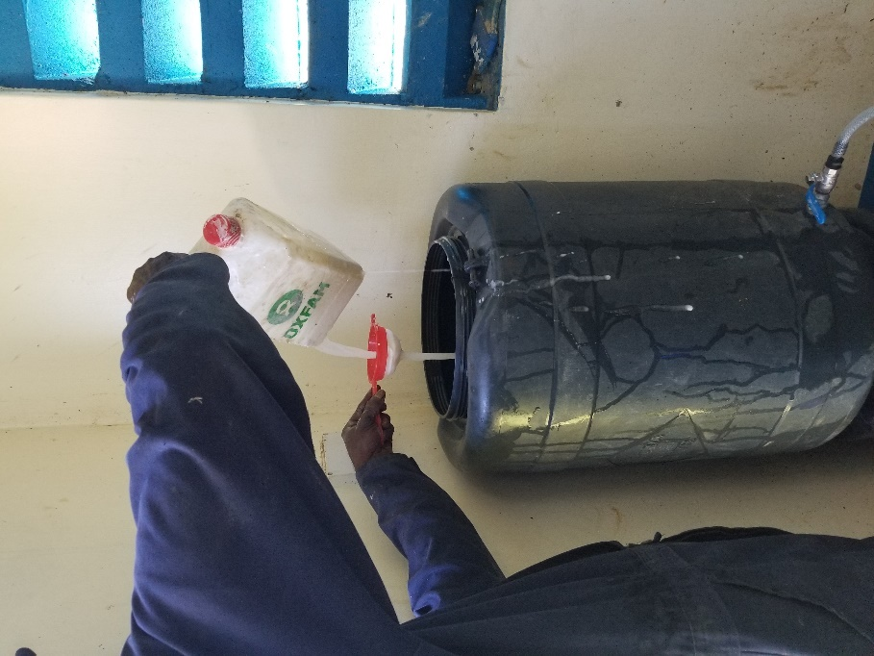
Picture3 – Preparing Alum Stock Solution for Suction Side Dosing

Testing the Lamella System at Various Flow Rates
Test Run 1
- Influent rate -35m3/hr
- Raw water turbidity 80 NTU
- Alum dosing – Suction side dosing based on 10Kg Alum powder for 70M3 tank
Time | Influent turbidity, NTU | Influent flow rate, m3/hr | Effluent Turbidity, NTU | Effluent flow rate, m3/hr | Remark
9:45 AM | 80 | 35 | - | - | Raw water pumping started. It was observed that raw water flowing to the effluent chamber increased again.
11:45 AM | 80 | 35 | 70 | 3.5 | Tank filled and outflow started at the top outlet
12:00 PM | 80 | 35 | 70 | 5 | The lower outlet opened to avoid overflow on the lamella block and to establish steady flow.
12:30 | 80 | 35 | <70 | 35 | -Steady state flow established but effluent turbidity is not decreasing. Pumping stopped.
1:00 PM | - | 0 | 40 | 3 | Turbidity measured at top outlet, with no inflow rate
2:00PM | - | 0 | 30 | <3
3:00PM | - | 0 | 28 |  | Turbidity measured at top outlet.
4:00PM | - | 0 | 15 | <<3 | Washout opened and the water released back to the d/s of the dam.

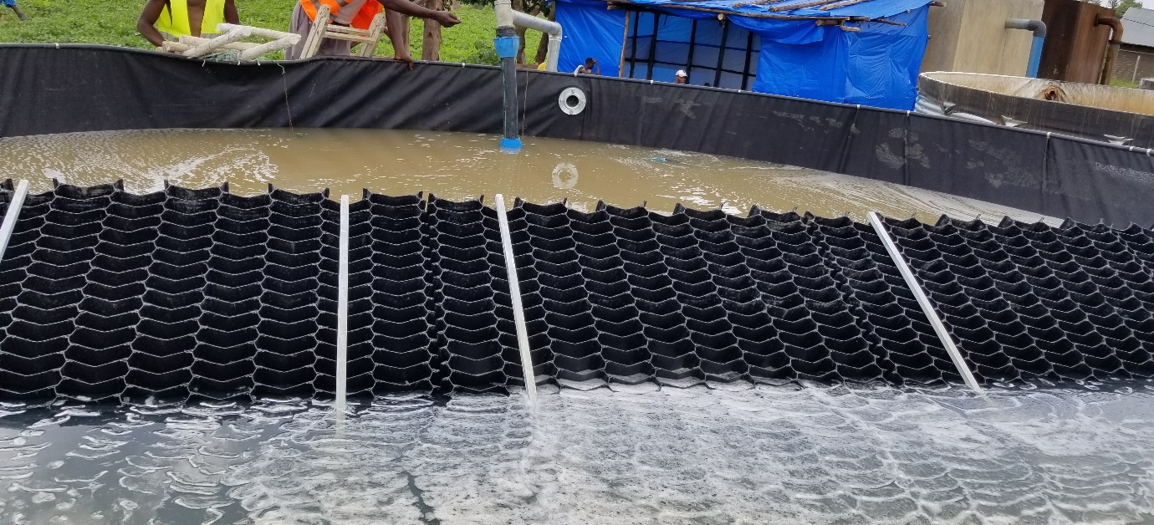
Picture4 – Influent and Effluent side of the tank after steady state established at 35m3/hr.
Observations
- Influent Side
- The diffuser has able to release raw water mostly through the holes of the top horizontal perforated pipe more than the lower two. As the number of the orifices were determined based on Max 45 m3/hr, this might be the case.
- Once the diffuser is submerged in the water, no turbulence was observed on the surface of the influent side chamber of the tank. No short circuit caused by the inlet pipe.
- Effluent side
- The raw water seepage coming from the gaps filled effluent chamber of the tank (about 1.5m) has maintained the turbidity level higher towards the effluent outlets. The seepage mostly come through the gap between tube blocks and side walls at both ends.
- It was observed that the water flowing up through the tubes are clearer. A pool of clearer water was observed on the face of the tube outlet areas. However, this couldn’t expand towards the outlets, hence effluent turbidity remains high.
- Steady flow couldn’t be established with the top outlet alone and with the influent flow rate at 35m3/hr. It needs opening the second outlet (10cm lower than the top outlet) that inflow and outflow can balance, and steady state flow established.

Test Run 2 - Test Run at Reduced Influent Rate – 22m3/hr
Noting that the first test at 35 m3/hr couldn’t able to reduce the turbidity level to the desired level, second test was set up to check the performance at a reduced flow rate. A reduced influent rate was determined using the gate valves we have installed for flow control purposes. The gate valves at the tee branches from the pressure line and two gate valves installed at the inlet to the tank were used. The two gate valves at the tank is able to divert the excess flow to adjacent T70 tank for parallel running with the lamella tank.
And manually measured the inflow rate at the tank using bucket and stopwatch method. Influent flow rate was able to set at 22m3/hr
Influent/raw water turbidity: The influent turbidity level was measured at the inlet to the tank using turbidity tube. And it was found out that 150NTU. Heavy rain falls the previous day has increased the turbidity level of the raw water at the reservoir. 150 NTU was the turbidity at the be beginning of the test. However, it was later observed this level has decreased over the day to 70 NTU.
Pumping of raw water mixed with alum solution was started at 11:00AM.
- Influent rate -22m3/hr
- Raw water turbidity 150 NTU
Time | Influent turbidity, NTU | Influent flow rate, m3/hr | Effluent Turbidity, NTU |  | Effluent flow rate, m3/hr | Remark
Time | Influent turbidity, NTU | Influent flow rate, m3/hr | Upper outlet | Lower outlet | Effluent flow rate, m3/hr | Remark
11:00AM | 150 | 22 | - | - | - | Raw water pumping started. Turbidity at the start 150 NTU.
2:12 PM | - | 22 | 30 | - | - | Tank filled and outflow started at the top outlet
2:25 PM | - | 22 | 30 | - | -
2:40 PM | - | 22 | 26 | - | - | The lower outlet opened to avoid overflow on the tube blocks.
2:55 PM | - | 22 | 21 | 40 |  | Both outlets opened. Adjusting flow control valve of the lower outlet to establish constant water level inside the tank. Steady state flow established at 22m3/hr
3:05 PM | - | 22 | 22 | 40 | 22 | All outflow rates measured. 3m3/hr upper outlet and 19m3/hr lower outlet.
3:20 PM | - | 22 | 21 | 35 | 22 | Steady flow
3:30PM | - | 22 | 20 | 35 | 22 | Steady flow
3:45PM | - | 22 | 18 | 30 | 22 | Steady flow
4:00PM | - | 22 | 15 | 29 | 22 | Steady flow
4:10PM | - | 22 | 15 | 25 | 22 | Steady flow
4:20PM | - | 22 | 15 | 25 | 22 | Steady flow
4:30PM | - | 22 | 15 | 25 | 22 | Steady flow – desired level of turbidity wasn’t achieved.
5:00 PM | 65 | 22 | 15 | 25 | 22 | Raw water turbidity dropped to 65

Observations and Notes
Effluent Side
- The overall turbidity reduction level achieved at 22m3/hr was 25 NTU. The desirable level of turbidity (<5 NTU) couldn’t be achieved.
- Two effluent outlets were used to stabilise the water level inside the tank and established steady inflow - outflow. The upper outlet (3m3/hr) and the lower outlet (19m3/hr) were measured.
- Turbidity level measurement was conducted by turbidity tube. The precession is subjected to the person taking the reading and the fluctuation of the sun light. To void inconsistency, the same two persons take each reading.
Influent Side
- The raw water turbidity was unusually high. This was due to the heavy rainfall in the evening of the previous day. but the raw water turbidity has drop significantly to 65 over a period of 6 hours when the tank filling and testing was conducted. It was also apparent the effluent turbidity was also dropped during testing.
- It wasn’t possible to measure more raw water turbidity levels between the beginning and the end of test because the raw water pumped during the testing period was mixed with Alum. To avoid interruptions of Alum dosing to measure the turbidity, we were able to measure the raw water turbidity at the beginning and end of the test.

Test Run at Reduced Influent Rate – 18m3/hr
Pumping of raw water mixed with alum solution was started at 9:15AM
- Influent rate -18m3/hr
- Raw water turbidity 60 NTU
Time | Influent turbidity, NTU | Influent flow rate, m3/hr | Effluent Turbidity, NTU |  | Effluent flow rate, m3/hr | Remark
Time | Influent turbidity, NTU | Influent flow rate, m3/hr | Upper outlet | Lower outlet | Effluent flow rate, m3/hr | Remark
9:15AM | 60 | 18 | - | - | - | Raw water pumping started. Turbidity at the start 60 NTU.
1:00 PM | - | 18 | 30 | - | - | Tank filled and outflow started at the upper outlet
1:45 PM | - | 18 | 26 | - | - | The lower outlet opened to avoid overflow on the tube blocks and to establish steady flow.
2:00 PM | - | 18 | 21 | 21 | 18 | Both outlets opened. Adjusting flow control valve of the lower outlet to establish constant water level inside the tank.
2:15 PM | - | 18 | 20 | 22 | 18 | All outflow rates measured. Steady flow rate established at 17m3/hr. 3m3/hr upper outlet and 15m3/hr lower outlet.
2:35 PM | - | 18 | 19 | 22 | 18 | Steady flow
3:00PM | - | 18 | 20 | 25 | 18 | Steady flow
3:30PM | - | 18 | 20 | 25 | 18 | Steady flow
4:10PM | - | 18 | 20 | 25 | 18 | Steady flow
4:20PM | - | 18 | 20 | 25 | 18 | Steady flow
4:30PM | - | 18 | 20 | 25 | 18 | Steady flow – desired level of turbidity wasn’t achieved.
5:00 PM | 60 | 18 | 20 | 25 | 18 | -Raw water turbidity remained at 60  - the water in the tank was left full for turbidity test in the morning
9:00Am next day – 20th April | - | - | 15 at top of the tank |  | - | - After 15hrs storage in the lamella tanks, turbidity reduction remains more than the desirable level.

Discussions on Test Findings & Feedbacks - 1
A discussion was held with Karl and Brian on 19th April 2021 based on the findings of the previous three tests at different flow rates, feedbacks were received for further tastings. The feedbacks include.
- Fill the lamella tank the previous day and start the test the next day with full tank of clear water and observe the reaction for longer hrs.
- Run in parallel one of the existing T70 tanks (possibly the adjacent tank) likewise and check and compare the changes. Also compare the performance of both as simple sedimentation tanks. This will help to check if the lamella tubes installed in the middle of the tank affected the ability of the tank as sedimentation storage.
- Check if there are colour issues in the raw water - this is to check if the high turbidity of the effluent not due to the suspended solids or its due to other minerals in the raw water, given the aerators is bypassed.
To address the feedbacks step by step, arrangements were made on to set up a parallel run of similar T70 tanks with the lamella tank except no lamella tubes inside and the inlet diffuser. Thus, adjacent T70 tank was connected directly with the source bypassing the aerator -this involves pipe connection of the tank with the pressure line and installation of gate valve to control the flow.
Test Run4
The lamella tank was filled at 35m3/hr with suction side dosing. Similarly, the adjacent T70 tank was filled with similar pumping rate, dosing rate, raw water turbidity as the lamella tank. Once filled, both tanks were then left for settling storge while the turbidity reduction has been monitored with time. See the result in the table below.
Lamella Tank Result
Time | Influent turbidity, NTU | Effluent Turbidity, NTU | Remark
9:40 AM | 70 | 70 | Raw water pumping started. With suction side dosing
11:42 AM | 70 | 70 | Tank filled and outflow started at the top outlet. Pump stopped and left the water for settling.
2:00 PM | 25 | 15 | After 2hrs &18 min storage
6:00 PM | 18 | 15 | After 6hrs storage
6:00 AM | <5 | <5 | The next day morning – 18 hrs storage
 |  |  | The lamella tank was kept full up except the top 2 rows of the tubes– for the next steady flow test

Adjacent T70 tank Result
Time | Turbidity, NTU | Remark
11:43 AM | 70 | Raw water pumping started. With suction side dosing. (as soon as the lamella tank was filled)
1:40 AM | 70 | Tank filled. Pump stopped and left the water for settling.
3:40 PM | 20 | After 2hrs storage
6:00 PM | 18 | After 4hrs storage
6:00 AM | <5 | The next day morning – 16 hrs storage. We couldn’t measure the turbidity in the evening and nights to know the exact time it took to achieve <5 ntu

Full Lamella tank with clear water (<5 NTU) was tested with pumping at 35 m3/hr with suction side dosing.
Observation
Influent Side
- The colour of the water at the surface visibly changed in the first five minutes. But the turbidity tube test raised quickly to 30 NTU in the first 10 min and later 50 NTU in the next 15 min. No suspended flocs were seen on the surface until 40 min of steady state pumping.
- After 40 mins of pumping sizable flocs started to appear on the surface. Later after 1hr of pumping the whole chamber becomes full of flocs similar in looks to other T70 tanks. Turbidity raised 80 NTU (raw water turbidity).
Effluent Side
- The first 10 min the turbidity on the upper outlet remained around 5 NTU. Looking on the surface the water on the outlets of the tube remain clear while the turbidity and colour towards the outlet dropped to 15 NTU around after 20 min of pumping. The colour visibly gets darker towards the tank outlet than at the outlets of the tubes. After 1 hr pumping flocs start to appear on the surface of the water around the perimeter of the tank. The size of the flocs is smaller than that of the influent size.
- It was also observed that flocs movement is slow as the water in the effluent side chamber is still in general. And somehow the small size flocs stay suspended.
- Generally, after 40mins of pumping the turbidity level exceeds 30 NTU and gradually raised to 60 in 1.5 hrs of pumping. At this point the outflow from the tank outlets are with flocs and was visible as they passthrough the upper and lower outlets.
Major Findings:
- The suction side dosing works correctly as intended. As checked with parallelly run T70 tank. And the dosing itself is based on the Jar test conducted by laboratory with other parameters such as Iron and tested practical operation in the existing batch system. Coagulation and rapid mixings are Ok as fluffy flocs were formed at the influent side!
- It’s noted that the lamella tank requires more time than other parallelly run ordinary T70 tanks to clarify the turbidity to <5 ntu– this was tested parallelly with the same suction side dosing, flow rate of pumping and raw water turbidity level. Generally, smaller size suspended particles can’t settle easily once in the effluent chamber of the lamella tanks.
- Observation on flocs. The flocs formed on influent side of the tank is more or less the same as the flocs formed in other T70 tanks at least on the surface with suction side or batch dosing. However, there is better slow mixing happening in other T70 tanks due to the movement created by the inflow impact on the water pool. That might have contributed to smaller size floc formation and settlement unlike the T70 tanks, specifically on the effluent side. In the lamella tank the diffuser was intentionally ensured to avoid turbulence on influent side with outlet velocity less than 1.5m/s.
- On the effluent side, it seems majority of the water comes not via the tubes, rather short circuiting/preferential flow through gaps as seepage. Flocs are observed on the surface of the effluent side when the tank is full, but their sizes are smaller and there is not much movement or slow mixing in the effluent chamber wasn’t happening. The suspended flocs eventually made it to the tank outlet to keep the turbidity level high. Note that all rows of tube outlets were utilized except the top 2 rows to avoid overflow.
- If the back and side plates of the lamella arrangements were meant to stop raw water flow towards the effluent side, then it’s not serving the purpose, if not blocking flocculation process.

Discussions on Test Findings & Feedbacks - 2
On April 26th further discussion was held with Karl and Brian based on the findings of the last test results. Key challenges in achieving the targeted level of turbidity reduction were identified. Way forward actions need to address the challenges were agreed for further testing with the aim that the lamella tank performance is thoroughly diagnosed and understood.

Key Challenges Identified
- Seepage of raw water to effluent chamber: It was noted that as long as most of the water in the effluent chamber isn’t coming through the tube outlets, achieving the targeted turbidity reduction level is unlikely to attain.
- Flocculation/Flocculator: Adequate slow mixing is not happening in the Lamella tank with the current inlet pipe arrangement that settleable flocs are not formed to facilitate settling at the influent chamber. Evidence – the lamella tank performs less than the normal T70 tanks as a sedimentation tank. Observations proved the same on the effluent side that smaller size flocs remined suspended.

Way Forward Actions
- Close gaps to reduce seepage: Reduce the seepage/preferential flow of the raw water that majority of the water in the effluent chamber come via the tube outlets as effluent, eventually the turbidity level can be reduced as clarified water through the tubes and beat the turbid raw water seepage. To achieve this, it was agreed to
- Close major gaps using external use expanding foam and seal with Silicon sealant.
- Further improve the joint between the Lamella frame adjuster plate and the corrugated iron sheet of the T70 tank by inserting a plain iron rigid iron plate between the corrugated iron sheet and the liner that the foam can be applied between rigid surfaces and close gaps.
- Improve Flocculation Process: Provide mechanism for improved flocculation at the influent chamber by inducing slow mixing. To improve the slow mixing process for creation of bigger size flocs and facilitate settling at influent chamber, it was agreed to change the inflow diffuser pipe arrangement in such a way that can create slow movement around the circumference of the tank.
Reducing Seepage and Improving the Flocculation
Procurement of Expanding foam and Silicon Sealant
Four cans of Expanding foam for external use and two cans of multipurpose Silicon sealants were procured in Kamaplla on April 30th.
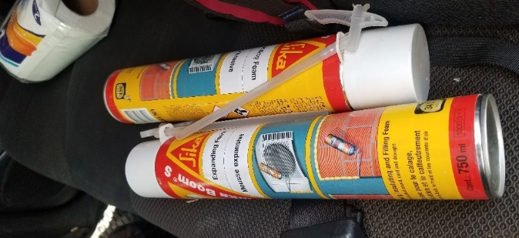
Picture5 – Expanding foam for External Use
On 1st May, Preparation works were conducted
- The inlet diffuser was removed and modified for improved slow mixing. It was made a perforated vertical pipe to ensure mixing along the full tank depth and the horizontal pipe piece near tank floor was made blind pipe to avoid causing resuspension of settled flocs at the floor.
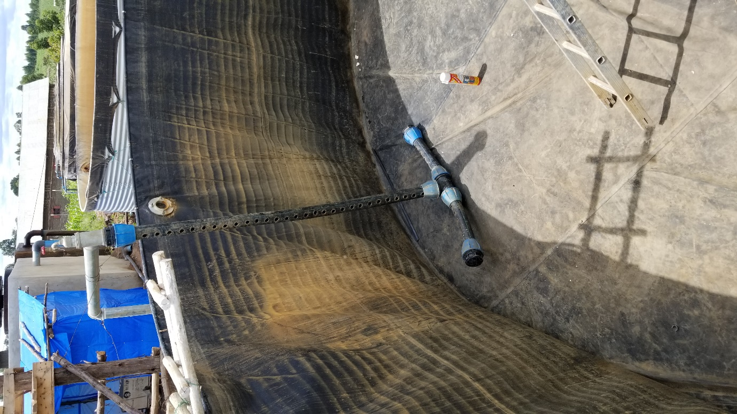
Picture6 – Modified Inlet Diffuser Pipe Arrangement
- 6cm plain rigid iron sheet was installed between the tank corrugated iron sheet and the liner. This involves partially removing two lamella tube blocks on both ends, the side wall and adjuster plates.
The adjuster plate was able to be attached with the tank wall very well. However, around the upper part it still has some opening and the side wall and adjuster plate has movement.
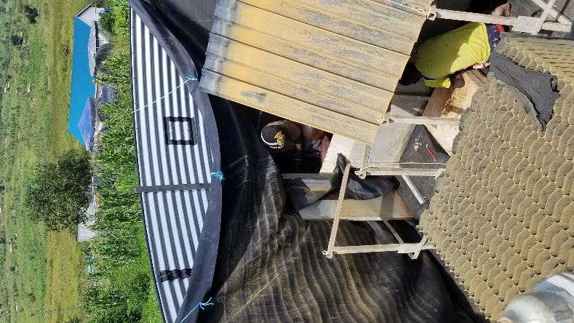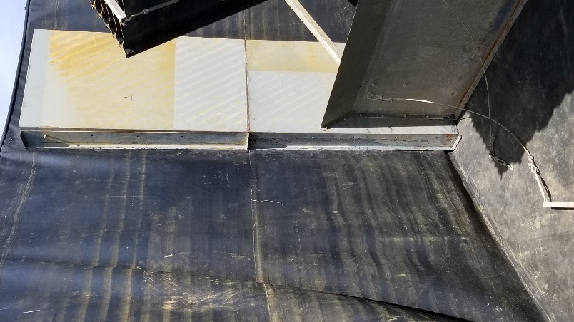
Picture6 – Removing the lamella Blocks and Closing the Gaps
With the aim of significantly reducing the seepage of raw water to the effluent chamber of the tank, all joints/gaps causing raw water seepage were closed with expanding foam and sealed with Silicon.
- Gaps at joints between the lamella stanchion frame and the liner (at the floor and sides)
- Gaps between the tube blocks with the side wall at both ends. This require pumping the foam into the tubes of half lamella profiles which touches the side wall plate at the end of the stanchion frames blocks. The foams were applied from the inlet side at the bottom, the gap at the side and the lower outlets of the tubes.

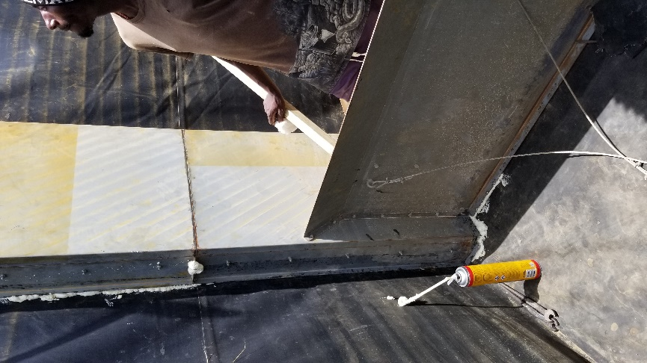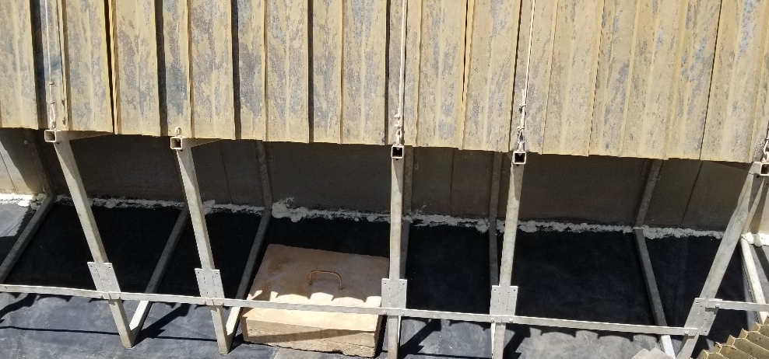
Picture7 – a) Applying Expanding Foam at Around the Gaps
- At the gaps at contact surface between the tube blocks and the back-wall plates
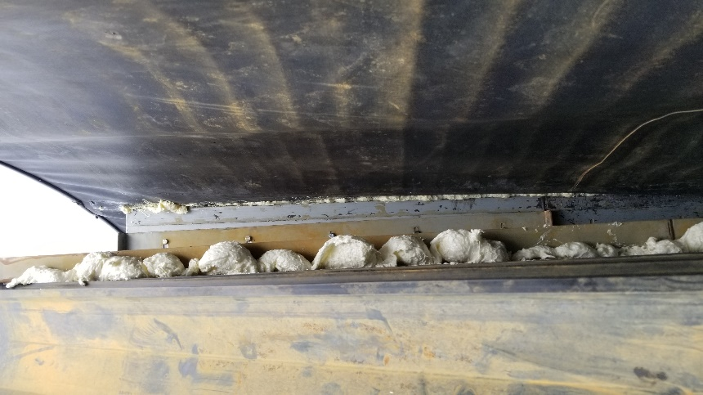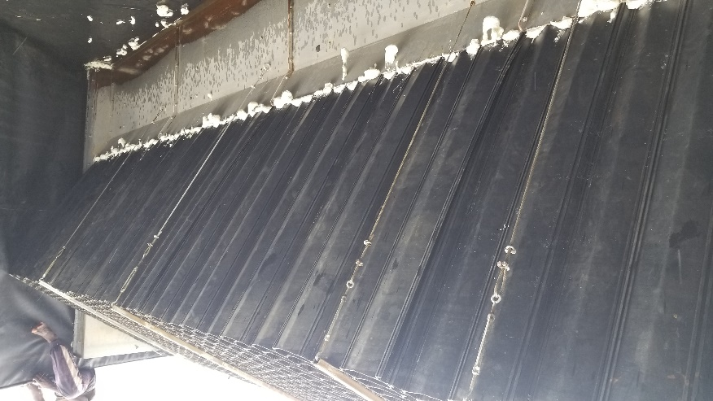
Picture7 – b) Applying Expanding Foam at Around the Gaps

- Apply silicon to seal the joints
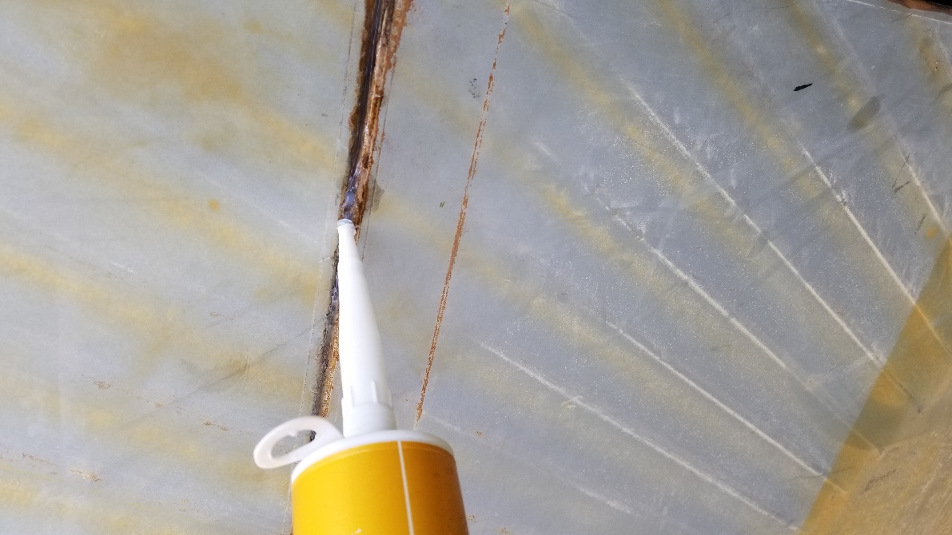
Picture8 – Applying Silicon Sealant
- Left the foam and the silicon seal for 24hrs for proper setting and drying
- To protect possible overturning due to the high hydrostatic force on the lamella frame, 4 blocks of concrete each weigh 100kg where put on the base of the stanchion frame.
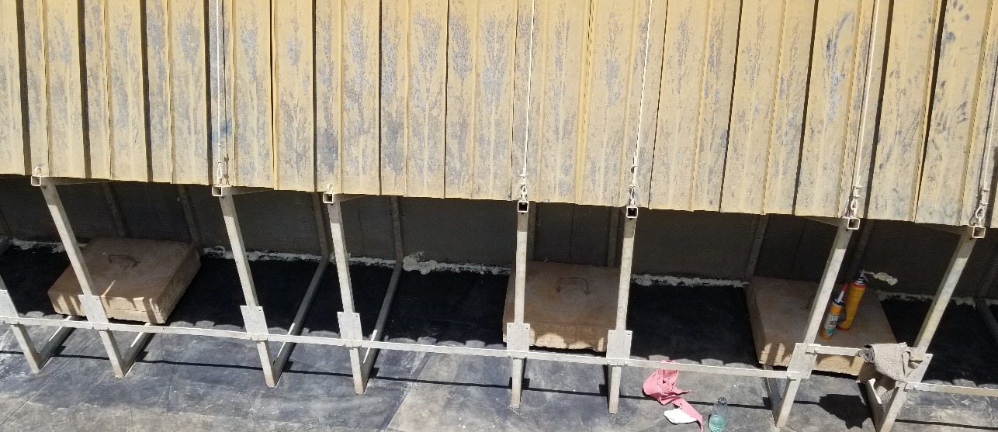
Picture 9 – Put Concrete Blocks to Counter the Overturning Moment
Test run 1-
After foaming and sealing the gaps and 24 hrs of drying, and with the modified inlet diffuser pipe, pumping was restated on 4th May 2021.
Observations-
At the influent side, with the new inlet diffuser pipe, it was able to ensure that improved slow mixing/flocculation of coagulated raw water around the circumference of the tank. The perforations along the inflow pipe was able to ensure mixing at every level as the water level raises up along the tank.
It was also evident with formation of good flocs in terms of size visually as compared to the previous tests both with the lamella tank and normal T70 tanks.
However, when the water level raises in the influent side of the tank, at the effluent side it was observed with minor seepage. As the water level raises to about 0.5 m in the influent side, while the effluent side is still empty, the T70 tank started creating sounds of stretching/contracting of the corrugated iron sheets due to the one side loading of the water. This gradually increased to create a tendency of overturning of the tank towards the influent side. It was observed that, at the base of the tank, the iron sheet contracted at the inlet side while the outlet side of the tank moved towards the inlet side to make the liner visible at the bottom. At this point it becomes clear that further pumping to the tank mean risking a total collapse of the T70 tank. Further the seepage towards the effluent side was increasing mainly at the side walls as the tank fills up. Later discovered that this was due to movement of the upper part of tank wall as the tank gets filled up.
To address this challenge, the effluent side of the tank has to be filled with water to balance both sides and avoid damage of the tank. To be able to observe visually the outflow from the tubes from the effluent side, it was necessary to partially fill the effluent side with clear water to a level of the lowest row of the tube outlets in the effluent side.
Raw water pumping restarted again at 35m3/hr while still having clear water on the tank that is transparent for eye observations. After establishing steady state flow at 35m3/hr, the observations were as follows:
Observations:
- When the tank gets full and steady state flow reached, a clear water on the effluent side and turbid water on the influent established.
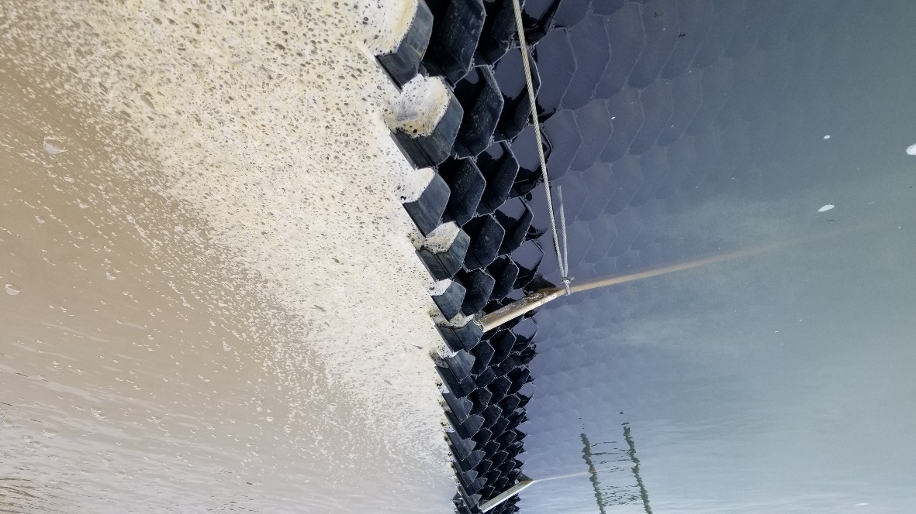
Picture10 – Steady State flow at Full Tank

- It was able to clearly observe that short circuiting of clouds of flocs were coming out on the left and right side of the effluent chamber, while less in the middle section at the junction between tube blocks. The flocs are coming from the lower depth than on the surface. This flocs are gradually increased the turbidity level of the water in the effluent chamber/tank outlets more than 25 NTU..after 3hrs pumping. See the flow of flocs on the both ends of the lamella tube outlets in the picture below and in the middle of the tube outlets as well.
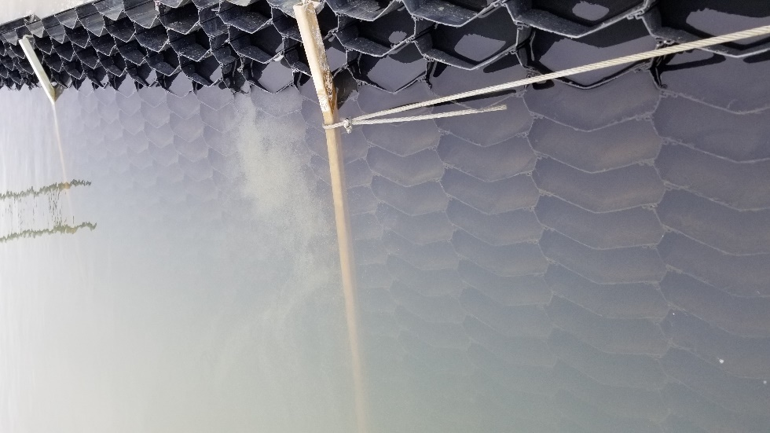
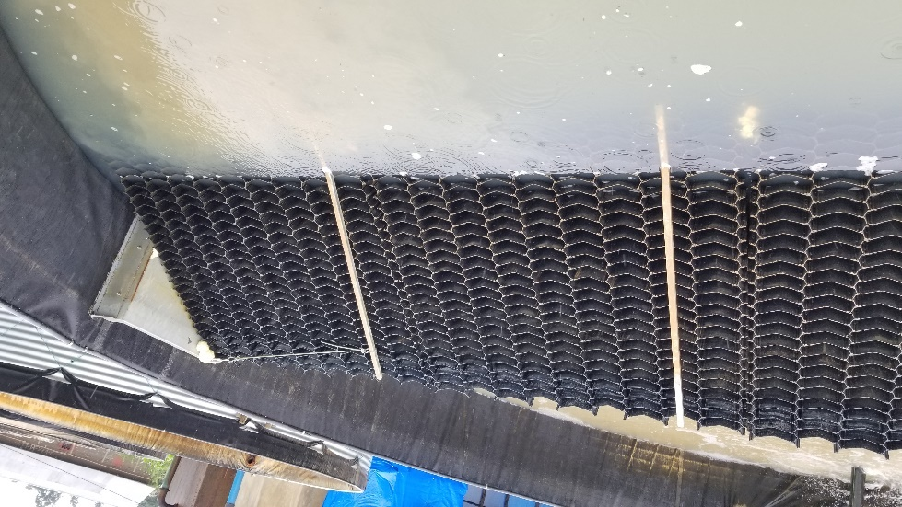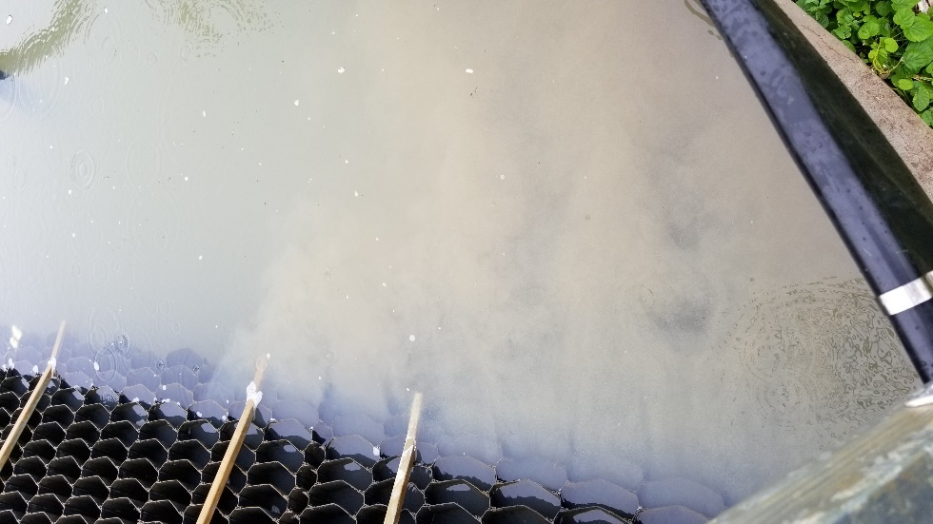
Picture 11 – Outflow of Flocs Through the Lower Tubes and Seepages
- Despite it was visible that some of the flocs are coming from lower tube outlets, however, it wasn’t able to tell for sure the source and extent of those short circuiting of flocs are from through seepage at the lower depth or the lower tube outlets of the lamella. To find out this, the pumping was stopped and left for 2 hrs storage to clarify the water for further pumping observation.

Identify Source and Cause of Short Circuiting of Flocs
The water in the tank was left for two hours storage to clarify. Before starting the next test, the turbidity level was tested in both chambers. Interestingly, the influent side was at 10 NTU while the effluent side was at 15 NTU. Better performance of flocs settling achieved on the influent side is attributed to the improved slow mixing in the influent chamber due to the change in the inflow diffuser pipe. This was also in line with eye observation of better floc formation in the influent side as mentioned above.
Pumping restarted at full tank and observation continued. After 20min of pumping the same flocs formed in the influent side and the short circuit of flocs were re-emerged on the left and right-side end of effluent chamber. The flocs were coming from the lower depth towards the surface and mixed to the clear water pool in the chamber to raise the turbidity level.
At this point, the tank outlet was wide opened to let outflow from the tank exceed the inflow 30 m3/hr that the water level in the tank gets lower as the pumping continue. This provides an opportunity to follow the sources of the flocs short circuiting down the lower level of the tube outlets on the effluent side – in reverse direction.
As the water level lowers, the flocs becoming visible more and more on both ends of the tube block and slight floc flows in the middle areas. By the time the water level passed the top 15 rows of tube outlets, it was clearly visible that the floc flow was coming from the lower tube outlets. Specifically, the flocs are coming out from the lower 10- 7 rows of the tube outlets (total outlets are 27 rows, the top 3 remained unused). By the time the water level reached the last outlets, the short circuit disappeared.
- Given the change at inflow diffuser arrangement (which improved the flocculation), it was now confirmed that the floc short circuit was coming from the lower 7-10 rows of the tube outlets. The lower the tubes, the more the flocs outflow rate. And higher at the lowest 3 rows of the tubes as it was like pipe flow. However, the outflow from upper tube outlets was slow as compared to the lower tube outlets.
- Despite closing the major gaps between the lamella and the T70 tank with foams and silicon sealant, seepage was still observed that gradually increase the turbidity level at the effluent chamber.

Identify Causes for short Circuit of Flocs at the Lower Tubes Outlets
After discussion with Brian and Karl, it was anticipated that the causes for the short circuit could be
- a) High inflow rate/loading via the tubes
- b) Turbulence created by the inflow diffuser discourage settlement around the tank circumference or create flow stream through the tubes
Thus, more tests were arranged with
- Reduced the pumping rate to 20m3/hr
- Modify the inflow diffuser in such a way that it suspended vertically around the circumference of the tank.
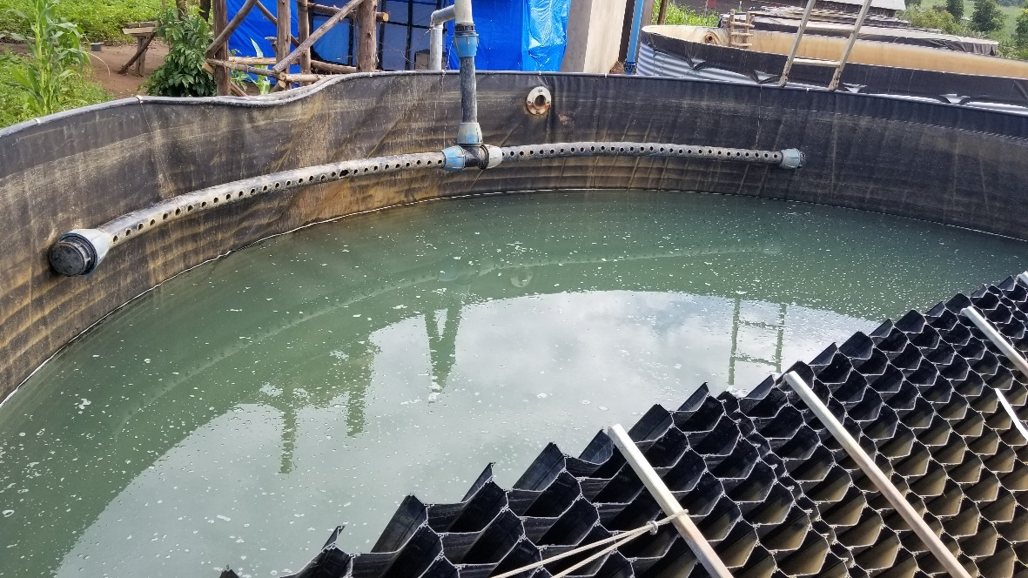
Picture12 – Modified Inlet Diffuser Pipe Around the Tank Circumference
- Check the uniformity of outflow along tubes outlets – attach pieces of Teflon at the outlet of the tubes (using supper glue) at the side and middle of the lamella tube block.
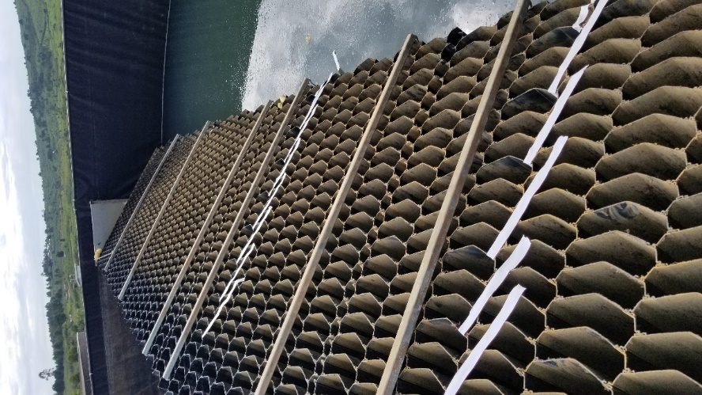
Picture13 – Attached Teflon Pieces to Check Even Outflow

Test Run
On 8th May raw water was pumped to the tank at 20m3/hr on partially full tank clarified water over via the modified inflow diffuser hanging on the top as indicated in the above picture. The diffuser was able to effectively distribute the inflow around the upper circumference of the tank influent chamber. The excess inflow of 15m3/hr was diverted to parallelly run T70 tank. The pumping was run for about 5 hr continues.
Findings
Influent side
- The inflow diffuser performs as intended – without any turbulence around the influent chamber of the tank. But unlike the previous diffuser arrangement, this arrangement was unable to initiate slow mixing in the influent chamber.

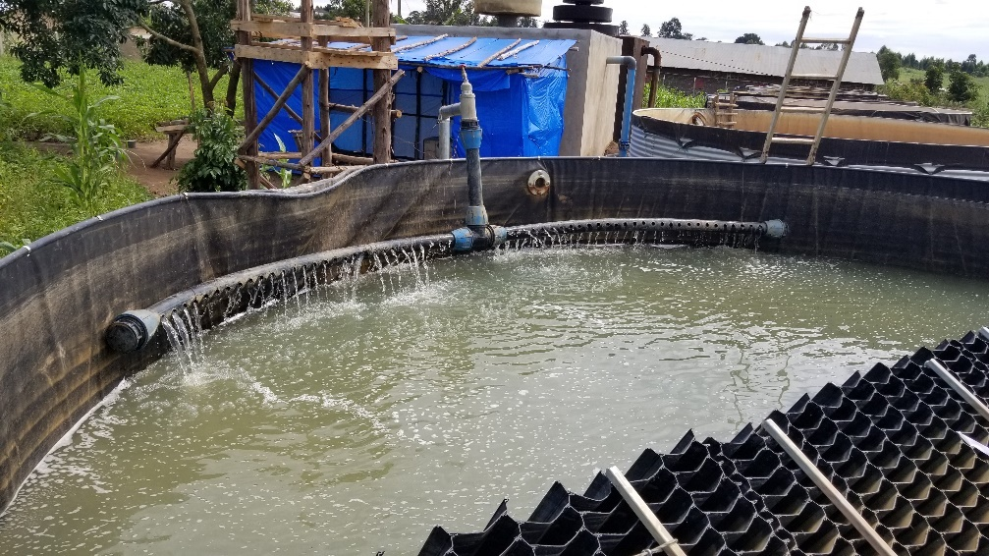
Picture14 – Distributed Inflow with the New Diffuser
- Flocs formation wasn’t encouraging as compared to the parallelly run T70 tank or the previous tests with vertically hanging perforated inflow diffuser. The flocs formed were not easily visible as they were smaller in size.
Effluent Side
- The overall Turbidity level gradually increased from <5 NTU to exceeding 25 NTU.
- All the pieces of Teflon attached have erected themselves up vertically. Showing no floc short circuiting, and outflow is distributed evenly across the tubes. However, the outflow rate is very low along the tube outlets that it fails to improve the turbidity level of the water in the effluent chamber.
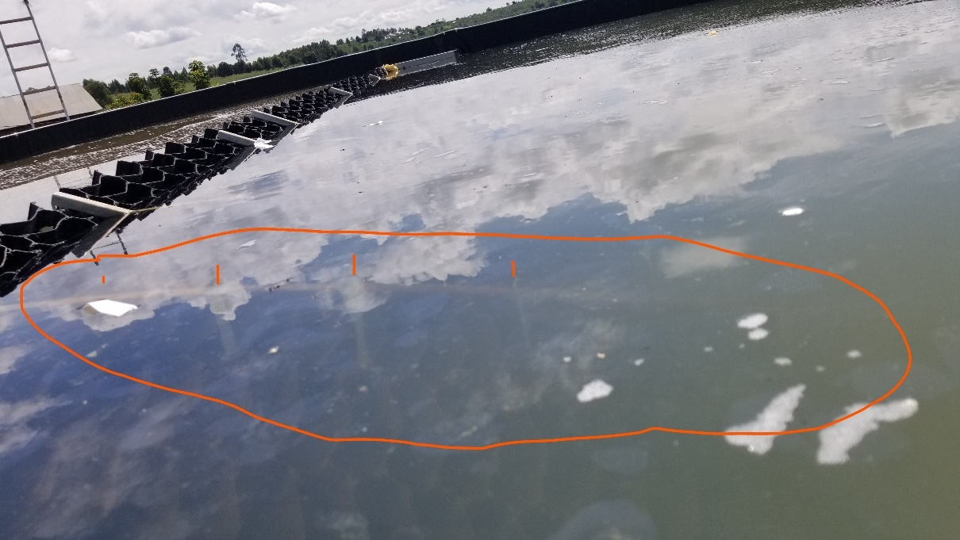

Picture15 – Performance of the Teflon Under the Tube Outflow Rate
- The seepage of raw water form other than tubes outlets may exceed the effluent from the tubes.

CONCLUSIONS
From the findings of the multiple trial tests above, the Lamella Tube Settler with the current set up in Kyaka II, Uganda can’t able to achieve the desired level of turbidity reduction (<5 NTU) at the tank outlet. The key parameters limiting the performance are:
- Suction Side Alum Dosing
- It was very difficult to calibrate the alum solution dosing rate and ensure air tightness with locally made dosing arrangements. Priming the dosing pipe and manual trial and error calibration of the dosing rate was challenging.

- Flocculation Process
- The performance of the lamella tank in creating flocs and facilitate settling at the influent side is highly depend on the inflow diffuser pipe arrangement and slow mixing it induced on the influent side.
- With a perforated diffuser pipe installed hanging vertically down the tank was able to induce slow mixing around the circumference of the tank as the water level increases and good sizes of flocs were formed. However, this flocculation process has resulted in short circuiting of flocs through the lower tube outlets into the effluent chamber – mostly on the sides.
- With a perforated diffuser pipe installed hanging horizontally around the circumference of the tank, slow mixing process were not happening on the influent chamber and the resulting flocs were very limited and fluffy/not settleable. This however resulted in evenly distributed effluent outflow from the tubes but at a very low flow rate (couldn’t measure the overall outflow rate from the tubes with the current lamella set up). The effluent flow couldn’t eventually reduce the overall turbidity level mixing with the turbid pool of water already in the effluent side of the tank (mainly seepages).
- With no perforated pipe?
- This leads to a conclusion that a controlled flocculation process is required before the flocculated water reached the inlet of the inclined tubes to facilitate creation of bigger flocs and settlement.
- Lamella System Set UP
- With the current set up it is not possible to avoidable mixing of the clarified effluent from the tube’s outlets with high turbidity seepage already filled the tank. As demonstrated by the trial test, the low effluent flow rate from the tubes can’t beat the seepage to reduce the turbidity level. Further, any flocs moved towards the effluent chamber can’t settle easily, hence moved through the tank outlet. On the top of provision of controlled flocculation process, the lamella set up should be improved to avoid the mixing.

RECOMMENDATIONS
- Alum Dosing: Oxfam Standard suction side dosing kit should be provided for alum dosing at the suction side of the pump to ensure complete air tightness (to avoid repeated priming of the dosing pipe) and calibration of the dosing rate.
- Flocculation Process: Controlled flocculation process MUST be provided before the inlet to the inclined tubes. Only then can able to test the performance of the lamella set up. As suggested by Caetano, this can be either provided as a separate kit as part of inlet or can be install within the T70 tank (at the base) like the flocculator in the IPS.
- Lamella Set Up: Improve the lamella set up to avoid mixing of the effluent with the raw water seepage at the effluent chamber. This can be done by modifying the tube blocks from cube to parallelogram that the tubes are inclined at same angle with the current set up. The effluent at the top of the tube outlets should be guided (without mixing with any raw water seepage) by provision of launders towards the eventual outlet from the tank. The effluent flow rate can effectively be measured if mixing is avoided.
- The T70 tank: In order to facilitate sludge removal, the floor of the tank should be modified in such a way that the sludges accumulated at the floor shall slid towards the washout with provision of min. slope.

